Great Bradley Church, Suffolk: Grave Number 172
Stephen Ryder
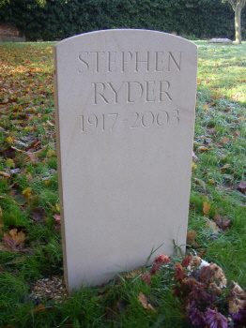 | STEPHEN  RYDER  1917 - 2003

