Great Bradley Church, Suffolk: Grave Number 167
Francis James and Mary Eliza James
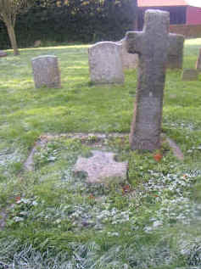 | In Loving Memory of  Francis James  Smith F.R.I.B.A  Who Died Dec 27th 1912  In his 69th Year  Also of  Mary Eliza  His Wife  Who Died Feb 8th 1917  In Her 70th Year  R.I.P
