Great Bradley Church, Suffolk: Grave Number 161
Jonas Taylor Smith and Harriet Hatch

IN
REMEMBRANCE OF
JONAS  TAYLOR  SMITH  BORN MAY 7 1826  DIED JAN 4 1875  NOT LOST BUT GONE BEFORE | 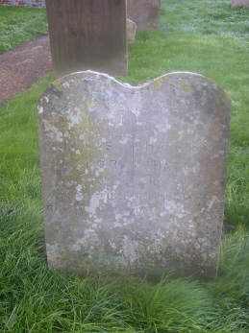 | HARRIET  HATCH  HIS WIFE  BORN JAN 15 1822  DIED AUG 14 1905  AT REST

