Great Bradley Church, Suffolk: Grave Number 160
George Smith and Mary Ann Smith

IN REMEMBRANCE OF
GEORGE SMITH  WHO DIED APRIL 5  1863  AGED 78 YEARS | 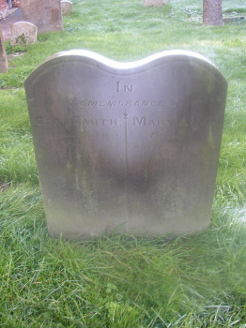  Footstone has  G.S | M.A.S  1863 | 1863 | MARY ANN  HIS WIFE  WHO DIED JAN 4TH  1863  AGED 69 YEARS

