Great Bradley Church, Suffolk: Grave Number 156
John Bowers

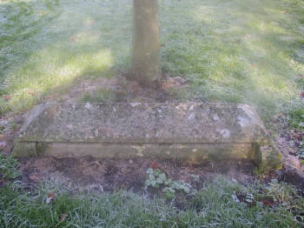
IN LOVING MEMORY OF
MR JOHN BOWERS
WHO DIED OCTOBER 26TH 1863
AGED 92 YEARS
[The engraving is along the length of the tomb]
This Tomb Grave being the only surviving grave in this area

