Great Bradley Church, Suffolk: Grave Number 155
Joseph and Ann Mitchell

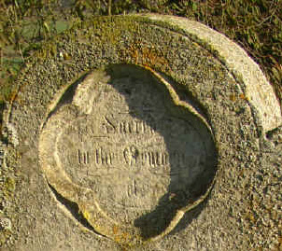
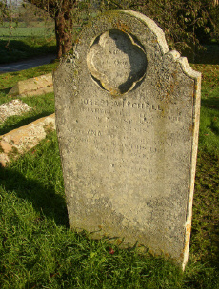 | 