Great Bradley Church, Suffolk: Grave Number 146
Joanna Seeley Day and William Day
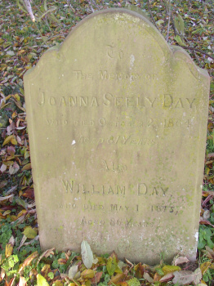 | TO  THE MEMORY OF  JOANNA SEELEY DAY  WHO DIED OCTOBER 2ND 1864  AGED 81 YEARS  -------<>-------  ALSO  WILLIAM DAY  WHO DIED MAY 14TH 1873  AGED 86 YEARS
