Great Bradley Church, Suffolk: Grave Number 140
Sarah Nice, Josiah Nice and Thomas Nice
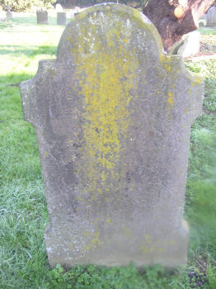 | IN  REMEMBRANCE  OF SARAH NICE  DIED AUGUST 15TH 1904  AGED 76 YEARS  JOSIAH NICE  DIED JANUARY 16TH 1908  AGED 76 YEARS  ALSO  THOMAS NICE  DIED FEBRUARY 2ND 1886  AGED 77 YEARS

