Great Bradley Church, Suffolk: Grave Number 116
Percival Hampson Elwin Wilder, BA Oxon, Priest, Rector of this Parish.1942 ,
John McMahon Wilder, 1969, cremated remains. Also his wife Mildred Maria Wilder, 1966.
Percival Ernest,Tim, Wilder 1953 also his wife Dorothy May 1974;
The inscription to the memory of these members of the wilder family are engraved on the kerb wall of the monument and there is a plaque on the North wall of the Chancel inside the Church
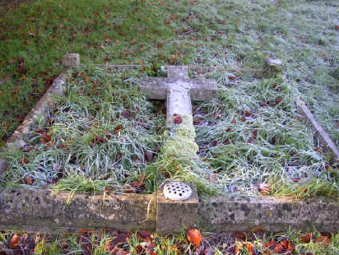
(engraved on the inside left hand side of the kerb)  JOHN MCMAHON WILDER 1898 - 1969 |  | (engraved on inside of top kerb)  IN LOVING MEMORY OF  PERCIVAL HAMPSON ELWIN WILDER BA OX  PRIEST RECTOR OF THIS PARISH  DIED JUNE 23RD 1942 AGED 71  ALSO HIS WIFE  MILDRED MARIA WATERS  DIED FEBRUARY 19TH 1966  (engraved on the right inside of the kerb)  PERCIVAL ERNEST [TIM] WILDER  DEP JULY 30TH 1953 AGED 54  ALSO OF HIS WIFE DOROTHY MAY  1899 - 1974  (engraved on the outside of the bottom kerb)

