Great Bradley Church, Suffolk: Grave Number 109
Ada Mary Sadler & Samuel Sadler
Stone Headstone with 2 Foot Stones marked AM 1903.
These footstones are numbered 109a and 110.

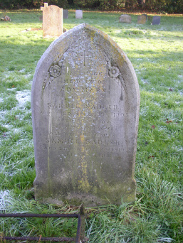 | IN LOVING  MEMORY OF  ADA MARY  WIFE OF  SAMUEL SADLER  WHO DIED MARCH 19TH 1903  AGED 50 YEARS  PEACE PERFECT PEACE  ALSO OF THE ABOVE  SAMUEL SADLER  WHO DIED APRIL 2ND 1919  AGED 80 YEARS  REST IN PEACE  Footstones say  S.S 1919 A.M.S 1903
