Great Bradley through the Ages: 6. The Late Middle Ages – Part c: 14th Century Changes
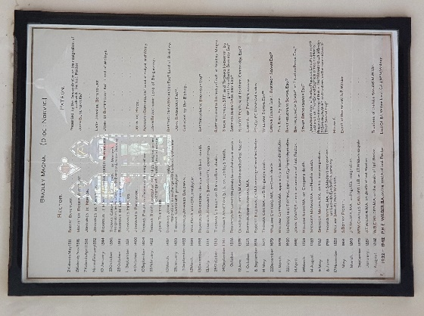
We have a number of sources illustrating aspects of life in Great Bradley in the 14th Century. One of these is the list of church rectors from 1311. Those of the 14th Century were: From 2nd May 1311, Robert Buteturt, (or Botetourt) presented by the Sequestrator (Bishop’s representative) on the resignation of Ludswick the last rector; 13th November, 1316, Magister Roger Buteturt, sponsored by Sir John Buteturt; 7th April, 1318, Johannes De Norton sponsored by Sir John Buteturt; 9th February 1332, Johannes De Paynton sponsored by Lady Joan De Botetourt; 10th January, 1344, Ricardus Le Morter (or le Mercer) De Berningham sponsored by Sir John De Butetourt, Lord of Woleye; 23rd October 1350, Thomas Gerond De Stratford on Mercer's resignation, an exchange with Everdon, Lincoln Diocese; 29th October 1361, Ricardus De Gretyngdon and 1st September 1391, Johannes Hercos. The full list is hanging at the back of the church and our website at https://greatbradley.weebly.com/rectors-from-1311.html.
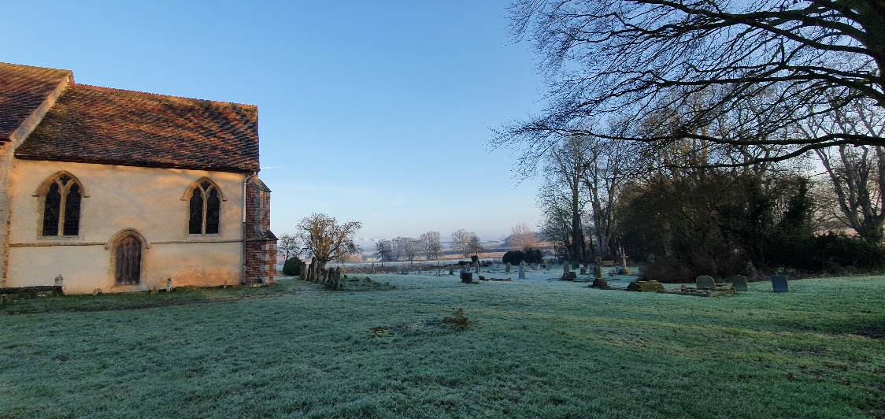
We have records of land transactions in the 14th Century. For example, the earliest known transaction is on 18th August 1310 where land in Brinkley was granted by William Wastle to John Kemp of Great Bradley. In 1311 there was a “release by Hugh de Lopham, clerk, to the prior and convent of Lewes for 20 pounds of all his rights in 100 acres in Bradeleye Magna [Great Bradley] in a field called 'Haldeleye' concerning which he had impleaded the said prior”; on 29th September 1334 John de Langeton released land to Walter de Wyght which he and John de Norton former rector of Great Bradley had; and on December 21st 1353 land was granted from John Botetourt to Walter de Wyght “formerly belonging to Symon de Hatfield, chaplain of the chapel to Great Bradley for 50 masses to be celebrated annually in the church of Great Bradley”.

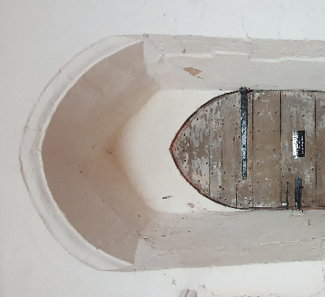
In the last article we learned that the church tower was built in the 14th Century. The chancel, pictured above was lengthened in the same period. It was subsequently been shortened to the size we see today.
There are two 14th Century window apertures and a priest’s door on the south side and one window aperture in the north wall of the chancel. You can see from the picture (right and above) that the outer 14th Century frame is older than the central stone lattice and the stained glass, which are probably 18th Century. The priest’s door (left and above) is set in the very thick wall.
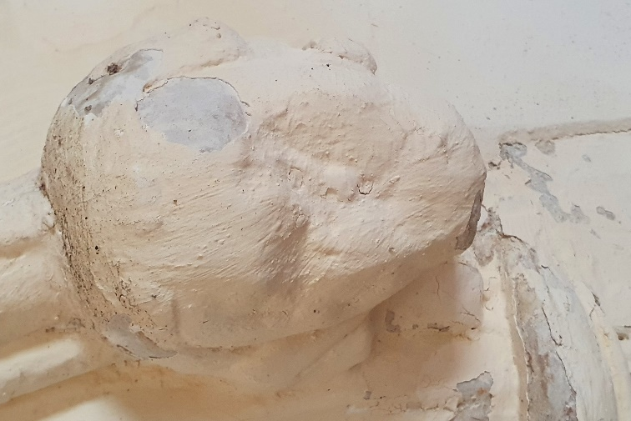
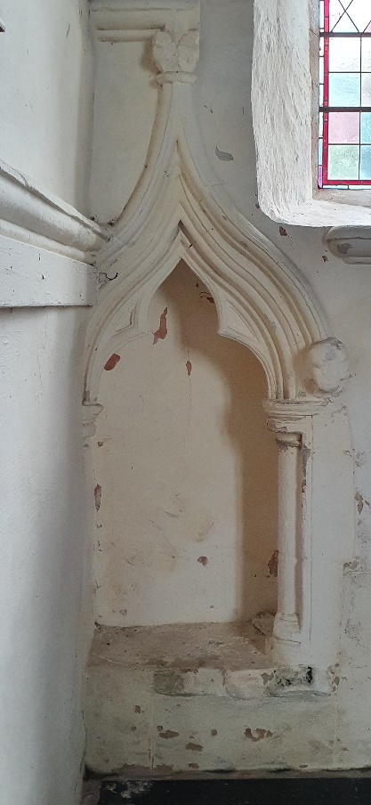
At the eastern end of the south wall of the sanctuary is a very fine 14th century sedilia. This is a stone seat, set into the wall that church ministers would have sat on during a service. The hood over the seat is in the form of a trefoil-headed ogee arch (i.e. formed by the intersection of two S-shaped curves with three leaves at a pointed apex). The arch rests upon semi-circular pilasters (columns) with moulded capitals and bases. The hood rests on a corbel in the form of head. Only the right one remains.
There is only one sedilia and you can see that it is partially chopped off at the eastern end because the chancel has been shortened since the 14th Century. When the chancel was at its original length there would probably have been three sedilia in a line along this wall.
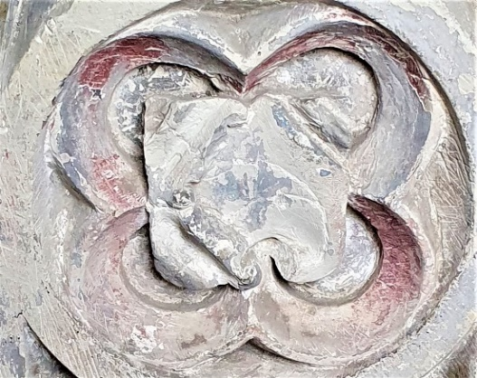
The octagonal lead-lined stone baptismal font is late 14th C. The panels are described as “quatrefoils with fleurons”, meaning four overlapping circles with a floral pattern in the centre. Fleurons and shields are carved beneath the bowl. The pillar is sculptured with trefoil-headed arches (trefoil means three leaves) with more fleurons round the base. The font was originally painted, and you can see that some of this 700-year-old red paint remains. It’s fantastic that the font is still in use after so long, as this family baptism from 2022 shows.

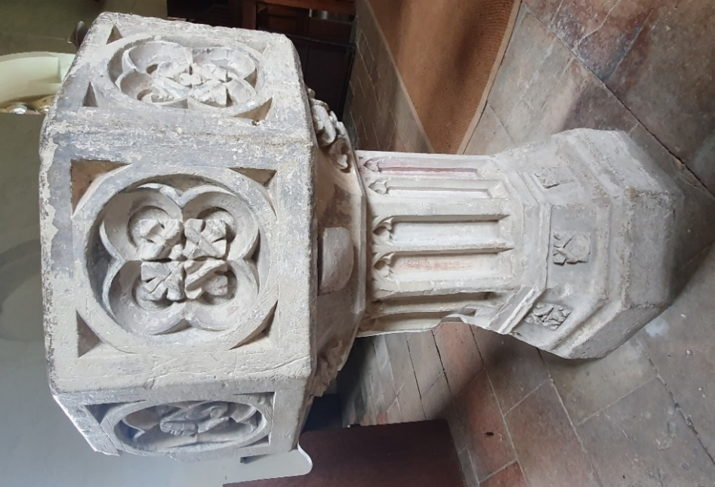

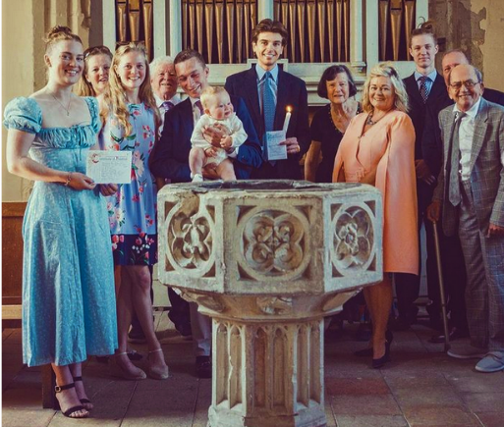
For more on the interior of the church see https://greatbradley.weebly.com/interior-description.html or support the Friends of Great Bradley Church at https://greatbradleychurch.com/

