Great Bradley through the Ages: 6. The Late Middle Ages – Part b: 14th Century Church Tower
In the 14th century (1300s) the original 12th Century Norman church of St Mary’s was altered. It is likely that the chancel windows on the north and south side were inserted (although the current glass and tracery is modern) and the chancel was lengthened (although it was shortened to its present length in the 18th Century).
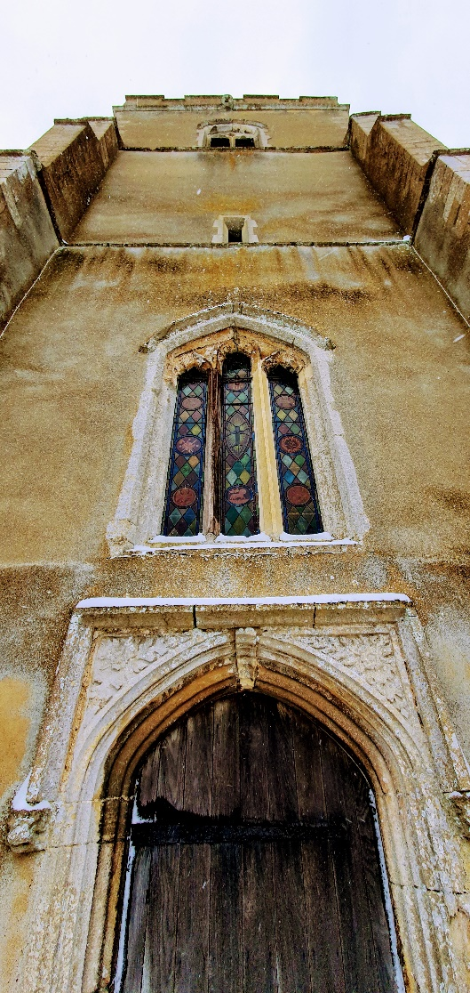
The most significant change was the building of the church tower. According to the history of the church by RW Tricker “The crowning glory of Great Bradley church is the handsome western tower.” It is believed to have been built in the 14th Century with 15th Century amendments in the English Late Gothic (or Perpendicular) style.
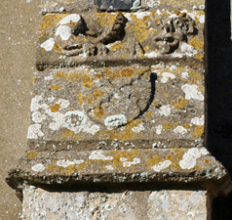
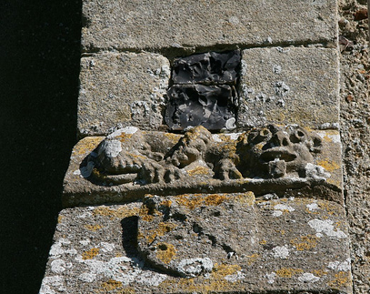
Its walls are strengthened by set-back angle buttresses at the corners. The set-offs (sloping ridges) of the buttresses have lions and shields carved on them (see below). These can be seen on the southern and western sides of the tower. The shields are the coat of arms of John Botetourt and described in heraldic terms as saltire engrailed i.e. a St Andrews [diagonal] cross with semi-circular indentations along the arms of the cross. John Botetourt was the owner of Great Bradley manor from about 1310. He died in 1385 and his sole heiress, Joyce Burnell, died in 1407 so this dates the buttresses to the end of the 14th Century. From 1311 - 1318 Roger’s brother, Robert, was the rector of St Mary's. We have the names of the rectors from 1311 and he is first on the list. See https://greatbradley.weebly.com/rectors-from-1311.html

The fine west doorway, in the Perpendicular style, has a square hood mould, which rests upon corbel heads and has roses and foliage in the spandrels (triangular areas between the door and the moulding).
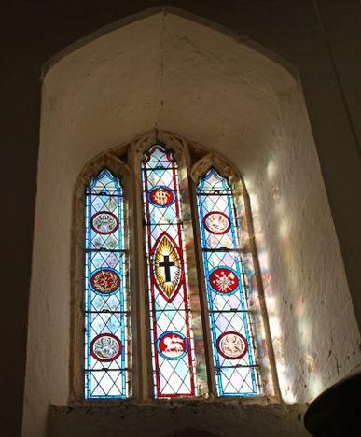
Above the door the three-light west window is also in the Perpendicular style. The modern stained glass depicts the symbols of the Lamb of God along with the motifs of the four Gospel writers, Matthew (winged man), Mark (winged lion), Luke (winged Ox) and John (Eagle).
Around the base of the tower and its buttresses is a chequered frieze of flint and stone.
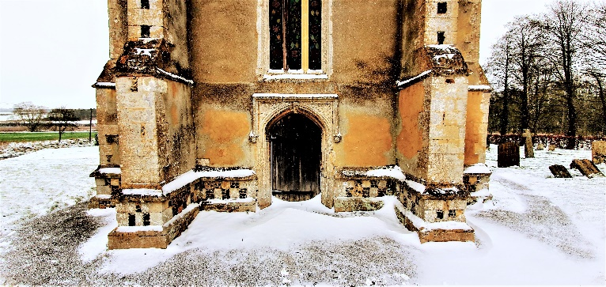

The staircase to the tower roof is on the south-east corner and the turret extends a few feet above the parapet (see pictures below). This occurs in several churches in this corner of Suffolk e.g. Withersfield and Hundon. The weather vane is 19th C and the banner on it is inscribed “H Long, 1824” for Hanslip Long who lived in the hall. You can see more pictures from the roof here: https://greatbradley.weebly.com/church-tower-roof.html
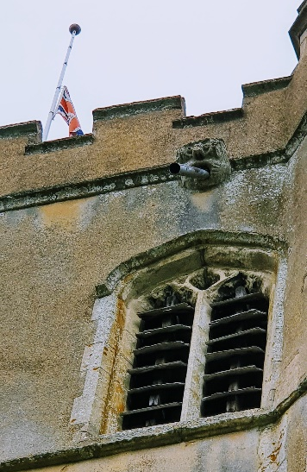
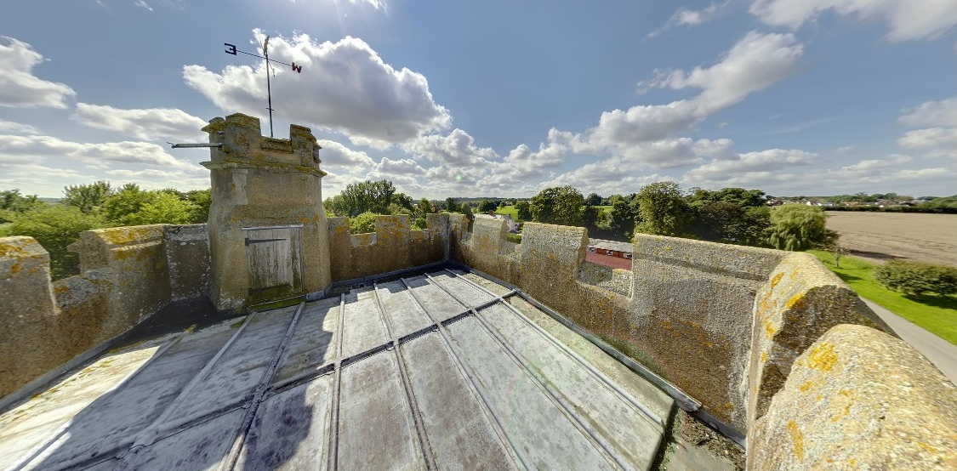
All four faces of the tower and the stair turret (left) are crowned with crenelated parapets.
This photo (right) shows the Union flag being flown at half-mast during the mourning for Queen Elizabeth II. It also shows a gargoyle, which drains water off the roof, above one of the three shuttered apertures on the north, south and west sides of the tower which illuminate the ringing chamber where the bells are.
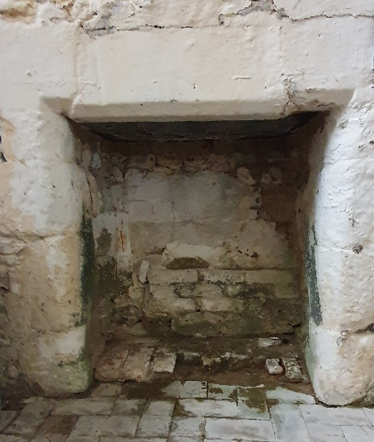
A very unusual feature of the tower is a fireplace at the base of the internal north wall, with a baffle about 16 feet up on the outer wall shielding the end of the chimney (see pictures). It wasn’t until the mid-12th Century that castles and stone houses were built with a fireplaces in a wall with a chimney, so it is a relatively early construction. It’s not known if the fire was used to bake communion hosts, to keep the priests warm or provide a warning signal, but it seems to be part of the original wall.

We will consider the church bells in a later article, but for more information about the church tower see the village website at https://greatbradley.weebly.com/tower-description.html and please support the Friends of Great Bradley Church at https://greatbradleychurch.com/

