Great Bradley through the Ages: 2. The Stone Age & Bronze Age
This information builds on the History of Great Bradley published in the year 2000 by a dedicated team of villagers led by Barbara Buchs and is downloadable from the website at https://greatbradley.weebly.com/published-histories.html
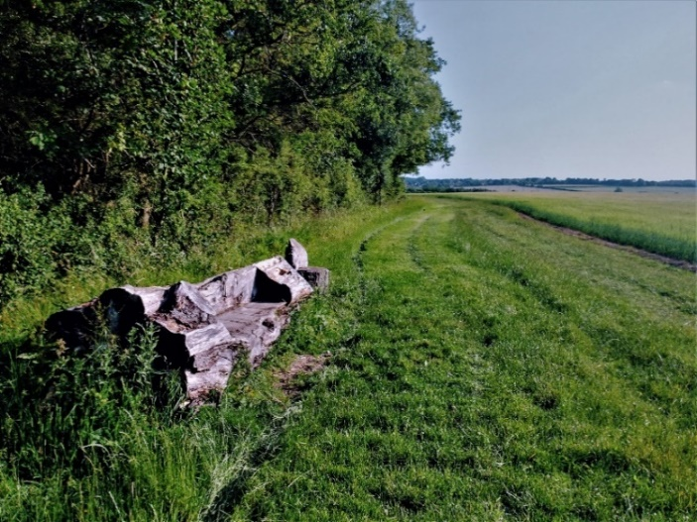
Generally, the most important necessity for living, and the one which often decided the site of a village, was water. Great Bradley was probably no exception and a settlement could have arisen here for two reasons. First, it was close to the river, which was likely to have been drinkable during the initial settlement and secondly, the river here was shallow enough for people to cross, as it still is today.
There is evidence that people lived in the period between the second and third glaciations, but it is not until the change in climate at the end of the last ice age, about 5,000 years ago, that agriculture as we know it came into being.
The first recorded people in the area are the Bell-Beaker people who migrated from Europe in about 3,400BC.
Edge of Bradley Park Wood, looking towards the village:
Site of the oldest evidence of human inhabitation in the area
The earliest evidence of people in the area is a flint pick axe and flint flakes found in the field next to Bradley Park Wood from the Mesolithic Era (Middle Stone Age, 9,000BC – 4,000BC)
The pictures show pick axe, made from a worked piece of flint embedded in a wooden handle and a Tranchet Axe of the type found near Bradley Park Wood. The blades are made from flint by chipping of ‘flakes’ of flint to leave a single long cutting edge. They may have also been trimmed to make it more comfortable to hold.
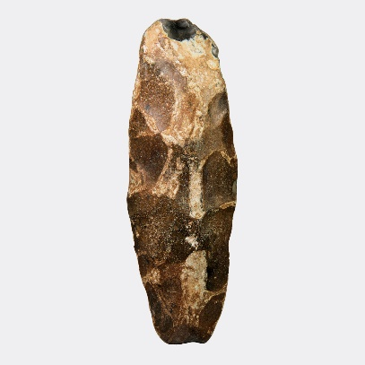
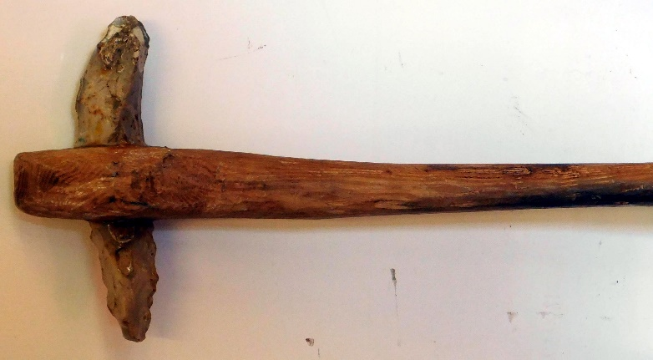

For the early settlers, who would have had to make a clearing in the valley, the river would have been quite a draw: fast flowing, clear and with easy crossing points. The area was more wooded than it is now and Bradley is derived from Old English (Anglo Saxon) meaning "wide clearing" which may have replaced earlier dialect names.
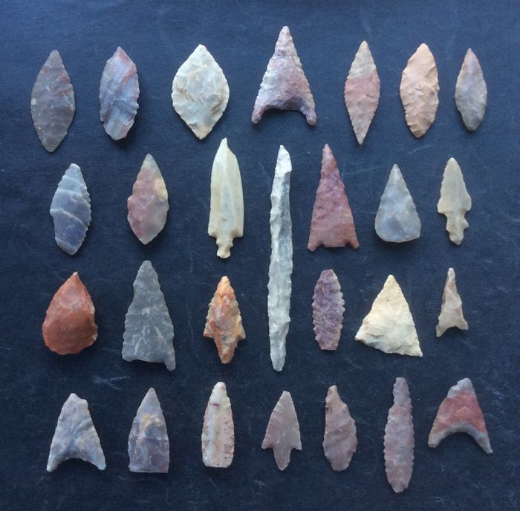
A Neolithic flint arrow head has been recorded, and a flint scraper has been recovered from the field behind the Old Rectory. Neolithic means new stone age and lasted between 4,000BC-2,200BC.
It is likely though, that with just stone tools, the woodland and the heavy clay soils would have made the area quite difficult to cultivate and live in. Other parts of the region, where the soil was lighter, were likely to be more populated.
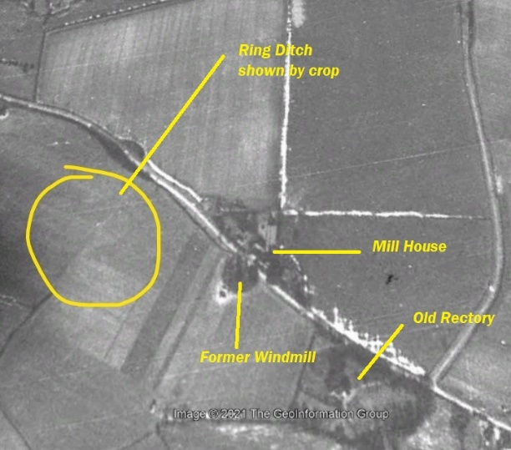
In 1984 a Bronze Age ring ditch, about 20m diameter, was identified from soil marks in the field to the left as you go down Bradley Hill. See enclosed photo from 1946. The darker ring can be seen with a much lighter mark at its centre. There was also some Neolithic/Early Bronze Age material found, consisting of 9 flakes, a scraper adjacent to the cropmark. Also three 4th century Nene Valley colour-coated pottery sherds. No trace of the ring ditch can be seen on the ground.

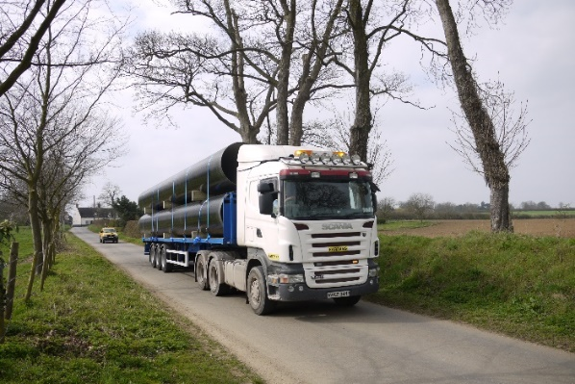
In 2011 a pipeline was put underground alongside the Kirtling Brook and the River Stour. This enables more water from the reservoir at Kirtling to be moved to Essex without having to put vastly increased volumes of water in these watercourses, which could disrupt the ecosystem of both the brook and the River Stour. It provides the most comprehensive archaeological record for the area. It found over worked 800 flints for example as well as ditches that could be part of field systems
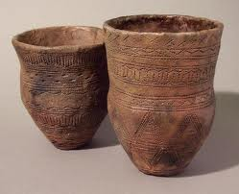
Pipeline sections on a truck in Hall Road, 2011
Examples of Beaker People pottery
Archaeological surveys undertaken when the pipeline was laid uncovered at least four locations where there were ditches and Bronze Age pottery (2,350BC – 701BC).
Three of these ditches run alongside the course of the current Kirtling Brook so perhaps they were linked to a stream for water or helped to form a defensive barrier.
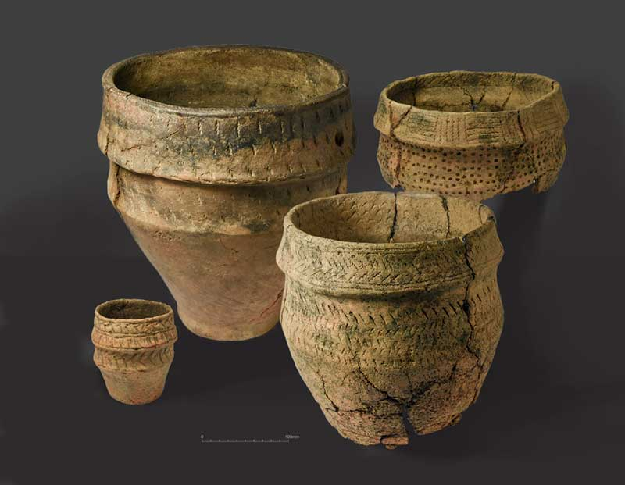
The fourth site, across the river from the current graveyard, found evidence of a watercourse, a ditch and a cremation site from the late Neolithic/late Bronze Age (3,000 – 701BC).
View towards the village showing the water pipeline (top left) being laid alongside Kirtling Brook
The cremation site contained pottery, flint arrow heads and tools such as scrapers and axe heads, along with human remains. The remains totalled about half a full person an appeared to have originally been wrapped in a fabric bag or cover. This implies that a great effort must have been put into collecting the bones after they had cooled on the funeral pyre.
Bronze Age Pottery used for cremations
It’s an interesting thought that people have been coming to live, work and die here for some 5,000 years and that, although those buried in the churchyard might be separated by thousands of years in time from those that were cremated by the river, their final resting places are only a hundred metres apart.
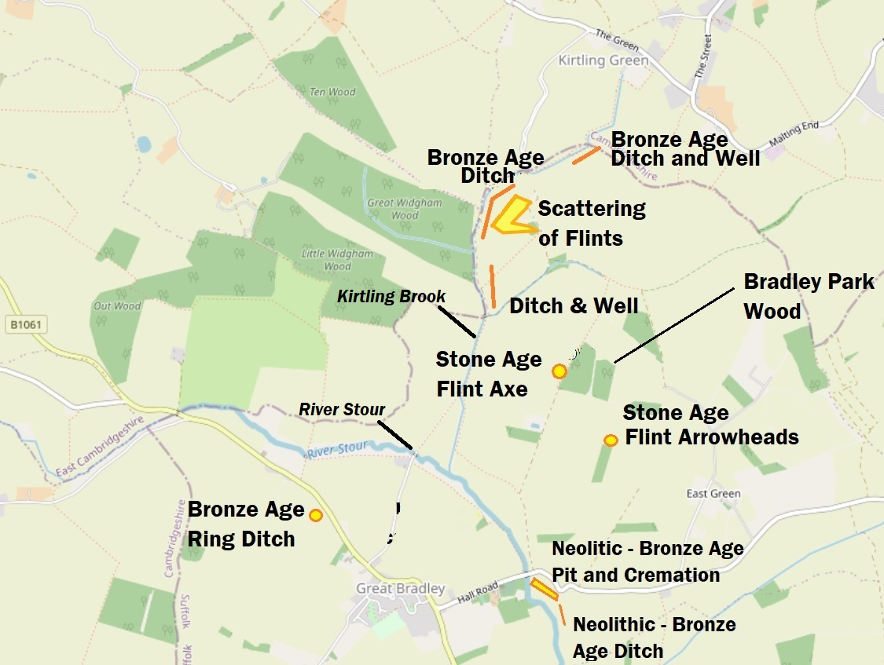
Figure 2 Map showing Iron Age and Bronze Age sites near Great Bradley
To find out more about the archaeology of the area see the village website https://greatbradley.weebly.com/archaeological-finds.html. You can find more pictures and information about the water transfer scheme at https://greatbradley.weebly.com/water-transfer-scheme.html.

