Great Bradley through the Ages: 2. The Stone Age & Bronze Age
This information builds on the History of Great Bradley published in the year 2000 by a dedicated team of villagers led by Barbara Buchs and is downloadable from the website at https://greatbradley.weebly.com/published-histories.html
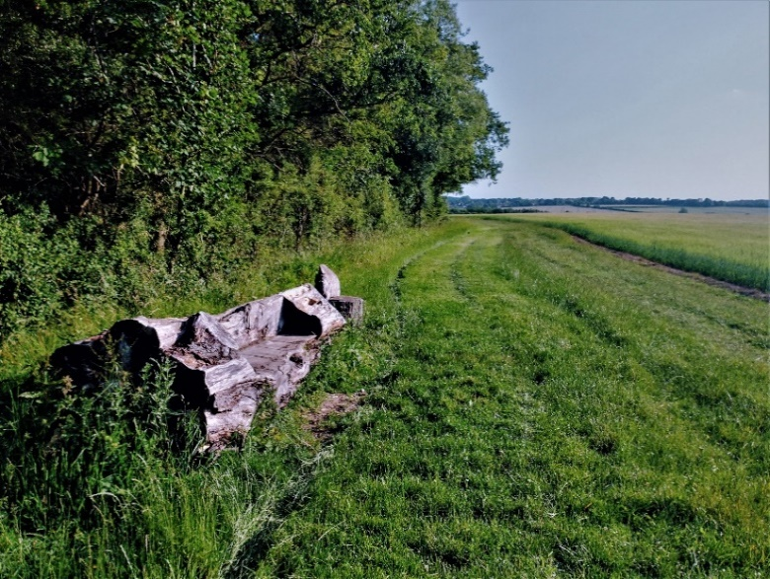
Generally, the most important necessity for living, and the one which often decided the site of a village, was water. Great Bradley was probably no exception and a settlement could have arisen here for two reasons. First, it was close to the river, which was likely to have been drinkable during the initial settlement and secondly, the river here was shallow enough for people to cross, as it still is today.
There is evidence that people lived in the period between the second and third glaciations, but it is not until the change in climate at the end of the last ice age, about 5,000 years ago, that agriculture as we know it came into being.
The first recorded people in the area are the Bell-Beaker people who migrated from Europe in about 3,400BC.
The earliest evidence of people in the area is a flint pick axe and flint flakes found in the field next to Bradley Park Wood from the Mesolithic Era (Middle Stone Age, 9,000BC – 4,000BC)
Edge of Bradley Park Wood, looking towards the village:
Site of the oldest evidence of human inhabitation in the area
For the early settlers, who would have had to make a clearing in the valley, the river would have been quite a draw: fast flowing, clear and with easy crossing points. The area was more wooded than it is now and Bradley is derived from Old English (Anglo Saxon) meaning "wide clearing" which may have replaced earlier dialect names.
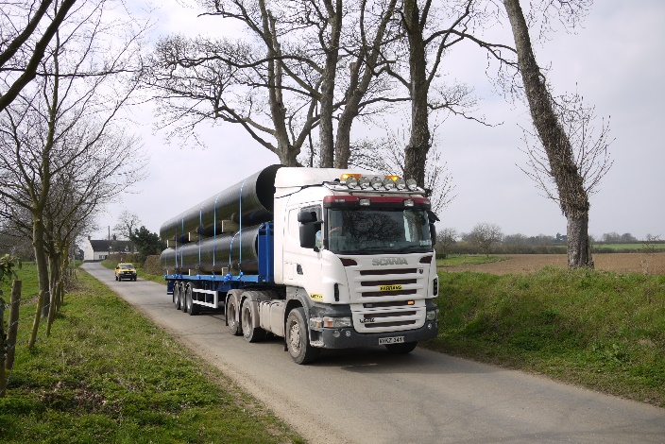
A Neolithic flint arrow head has been recorded, and a flint scraper has been recovered from the field behind the Old Rectory. Neolithic means new stone age and lasted between 4,000BC-2,200BC. It is likely though, that with just stone tools, the woodland and the heavy clay soils would have made the area quite difficult to cultivate and live in. Other parts of the region, where the soil was lighter, were likely to be more populated.
In 2011 a pipeline was put underground alongside the Kirtling Brook and the River Stour. This enables more water from the reservoir at Kirtling to be moved to Essex without having to put vastly increased volumes of water in these watercourses, which could disrupt the ecosystem of both the brook and the River Stour.
Pipeline sections on a truck in Hall Road, 2011
Archaeological surveys undertaken when the pipeline was laid uncovered at least four locations where there were ditches and Bronze Age pottery (2,350BC – 701BC). Three of these ditches run alongside the course of the current Kirtling Brook so perhaps they were linked to a stream for water or helped to form a defensive barrier.
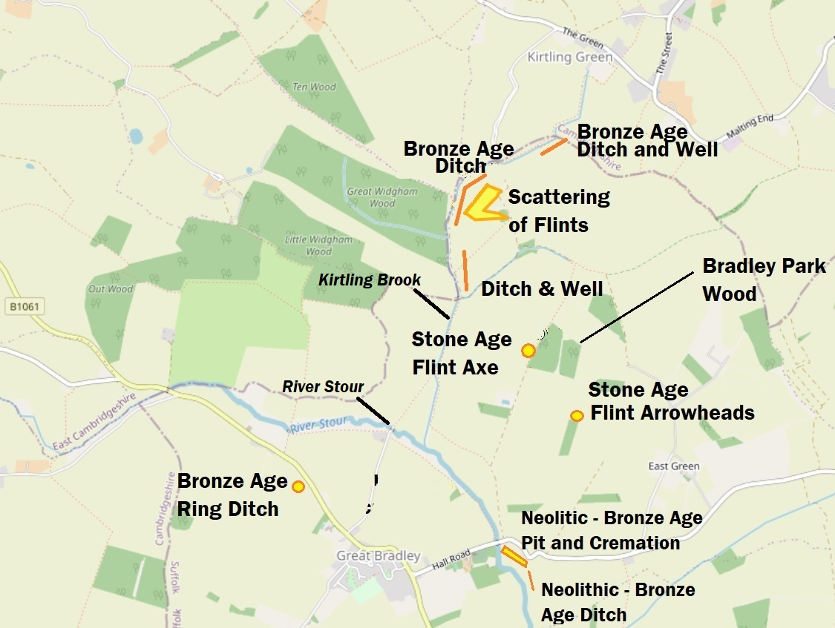
Map showing Stone Age and Bronze Age finds around Great Bradley
The fourth site, across the river from the current graveyard, found evidence of a watercourse, a ditch and a cremation site from the late Neolithic/late Bronze Age (3,000 – 701BC). The cremation site contained pottery, flint arrow heads and tools such as scrapers and axe heads, along with human remains.
It’s an interesting thought that people have been coming to live, work and die here for some 5,000 years and that, although those buried in the churchyard might be separated by thousands of years in time from those that were cremated by the river, their final resting places are only a hundred metres apart.
View towards the village showing the water pipeline (top left) being laid alongside Kirtling Brook
To find out more about the archaeology of the area see the village website https://greatbradley.weebly.com/archaeological-finds.html. You can find more pictures and information about the water transfer scheme at https://greatbradley.weebly.com/water-transfer-scheme.html.

