Gravestone Record from St Mary's Church, Great Bradley, Suffolk

Information about the churchyard and the graves is arranged in four different ways: You list the graves in surname, first name or grave number order or by row.

Each of the graves has a separate file of information, including a picture of the gravestone/ commemoration and some more information about the person, if available.

The location maps at the beginning (and in more detail at the end) of the directory show where the grave is located in the churchyard.

The information about the graves was prepared by Peter Smith of Fox Green, Great Bradley. The bulk of the survey was carried out in 2003-2004 and has been added to since then. The Parochial Church Council is very grateful to Peter for his dedicated work on this project.

For more information on the church, the graves and other archive information see the village website at www.greatbradley.org.uk

If you have any information you wish to share with us then please do contact us.

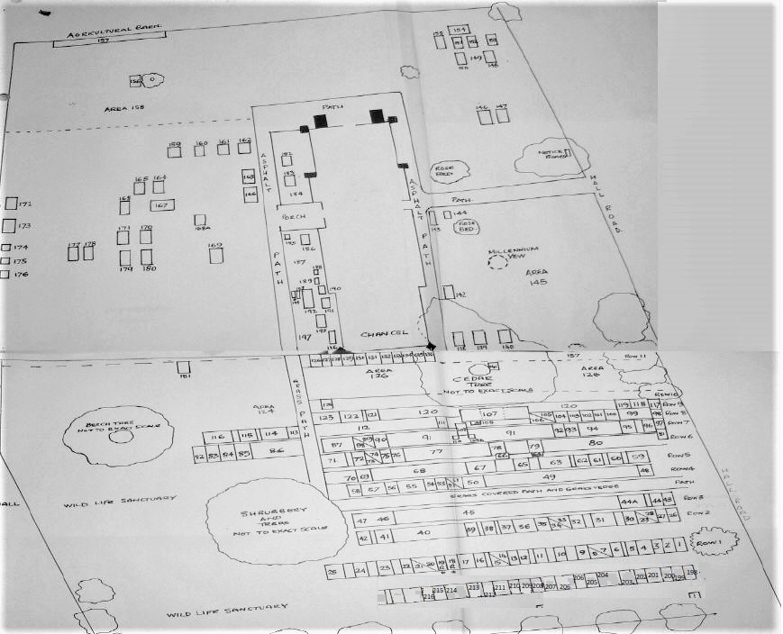

Plan of whole churchyard (see below for more detail)

Last Name | First Names | Grave No. | Row/ Area | Notes
NASH | Sarah | Plaque in church
NASH | William | Plaque in church
WILDER | Alice Mary | Plaque in church
WILDER | Annie | Plaque in church
WILDER | Charles | Plaque in church
SMITH | Martin | 0
PALMER | Bertie Thomas | 1 | Row 1 | Bertie Thomas Palmer 1969[1987 plan/notes indicate Gladys Palmer also buried in the grave, Gladys May Palmer entered in Burial Register 24 Jan 1987
RICHARDSON | Harry Ezra | 2 | Row 1 | Possible Grave; grass area, no markings.[1987 Plan/show H Richardson 1972 buried in the grave, Harry Ezra Richardson entered in Burial Register 27 Jan 1972 would seem to confirm as the next burial recorded after Bertie Thomas Palmer.] Mr Richardson was a farmer from East Green[source Queennie Rawlinson
RAWLINSON | Walter Henry | 3 | Row 1 | Walter Henry Rawlinson. 1972[husband of Queenie Rawlinson Evergreen Lane]
PAXMAN | Elizabeth Mary (Liz) | 4 | Row 1 | 1987 plan shows the grave. Confirmed by Queenie Rawlinson, 2004. Liz's parents, Thomas George & Martha Paxman are No. 177/178
JOLLY | Gabriel Percy | 5 | Row 1 | Gabriel Percy Jolly. 1974
PHILLIPS | Ernest | 6 | Row 1 | Ernest Phillips 1976 and Mary Phillips 1996 [Burial Register July 26 1996]
PHILLIPS | Mary | 6 | Row 1 | Ernest Phillips 1976 and Mary Phillips 1996 [Burial Register July 26 1996]
SMITH | Clement (Clem) | 8 | Row 1 | 1984 & 1987 plan & notes & Burial register P12, Feb 1973 confirm the grave
GRIMWOOD | Emaline | 9 | Row 1 | Grass area, no visible markings, attended area with flowers.[source 1987 plan indicates Emaline Grimwood of Bradley 1977 confirmed by Queenie May 2004]. P13 of Burial Register.
SMITH | Harold | 10 | Row 1 | Harold Smith 1979
MORNING | Harold (Lloyd) | 11 | Row 1 | Lloyd Morning 1980.[shown in Burial Register as Harold]
REED | Alice Dorothy | 12 | Row 1 | Leslie Albert Reed 1980 & Alice Reed [Alice Dorothy Reed entered in Burial Register P16 died aged 87 without entry as to abode and when buried]
REED | Leslie Albert | 12 | Row 1 | [Leslie Albert Reed 1980 & Alice Reed [Alice Dorothy Reed entered in Burial Register P16 died aged 87 without entry as to abode and when buried]
CHAPMAN | William Charles (Doody) | 13 | Row 1 | Grass area, no markings.  1984 & 1987 plan and p16 of Burial register confirm the grave
 |  | 14 | Row 1 | 1984 plans show this as a space
CLAYDON | Fred Sidney | 15 | Row 1 | Grass area no visible markings.[Fred Sidney Claydon shown as buried in the  grave, source 1984 plan/notes. 1987 plan shows the deceased as F S Claydon 1983  Burial Register confirms Fred Sidney Claydon buried 14 February 1983]  Burial register confirms grave & burial on 14 Feb, 1983
REED | Kathleen | 16 | Row 1 | The Burial Register confirms internment of ashes Kathleen Jane Reed 4 December 1983 and Agnes Jane Reed with no date shown and the next entry 1986.
PEARSON | Harry | 17 | Row 1 | Buried 22 June 1967
 |  | 18 |  | Plot 18 & 19 is a double plot reserved by Mrs Lewena Hawes and Mr David Hawes. The graves are in line with her grandmother, Jane Reed (No. 56)
 |  | 19 |  | Plot 18 & 19 is a double plot reserved by Mrs Lewena Hawes and Mr David Hawes. The graves are in line with her grandmother, Jane Reed (No. 56)
 |  | 20 |  | Possible space, but also possibly grave of P. Ionnides from 1990, which would logically have been in this plot
 |  | 21 |  | Possible space, but also possibly grave of P. Ionnides from 1990, which would logically have been in this plot
IOANNIDES | Peter | 22 | Row 1 | Peter Ioannides 1990
COWANS | Olive May | 23 | Row 1 | Double grave from 1986,but husband cremated and buried in Boston, Lincs, where he lived with his second wife
DUMYCZ | Osyp | 24 | Row 1 | Osyp Dumycz 1992
WATERSON | Margaret (Peggy) | 25 | Row 1 | Peggy Waterson 1997 [entered in Burial Register as Margaret]
KEMP | William Henry James | 26 | Row 2 | Possible Grave; unmarked grass area.[ Confirmed to be William Kemp by Queennie] William Henry James Kemp October 1966 P11 of Burial Register
BRAZIER | Barbara Phyllis | 27 | Row 2 | Barbara Phyllis Brazier 1966
 |  | 28 |  | Possible Grave; unmarked grass area
 |  | 29 |  | Possible Grave; unmarked grass area possibly a double plot.[1987 notes indicate possible further Claydon grave, Queennie confirms Claydon graves in this area with their exact location not known.]
CLAYDON | family? | 29 | Row 2 | Possible double plot for Claydon's, whose family is buried in this area
CLAYDON | Frank | 30 | Row 2 | Frank Claydon 1965
BALLS | Harry | 31 | Row 2 | Harry was a Boer War Veteran and coachman and gardener at Bradley Hall [source Joyce and Cyril Potter]. He lived at Sugar Loaf on the main street
BALLS | Julia | 31 | Row 2 | Wife of Harry
LING | Kathleen Rose | 32 | Row 2 | Unmarked tended grave; no headstone. Possibly Mary May Ling 5th Dec 1959, source her grand daughter Margaret who lives in Evergreen Lane Great Bradley.  Also the ashes of her daughter Kathleen Rose Ling 1996. P15 of the Burial Register. [source Maurice Goody and confirmed by Queenie]
LING | Mary May | 32 | Row 2 | Mary died in 1959. Granddaughter living in Evergreen Lane in 2004
COOTE | Nellie | 33 | Row 2 | P 8 of Burial Register for August 1958. Unsure if it is plot 33 or 43
COOTE | Nellie | 34 | Row 2 | P 8 of Burial Register for August 1958. Unsure if it is plot 33 or 43
CHARLTON | Matthew Winston | 35 | Row 2 | Matthew Winston Charlton 1958
 |  | 36 |  | Possible Graves unmarked grass strip 10 feet wide. 1987 notes indicate possible additional Balls family graves but doubted by Queenie [May 2004]
DIXON | Grace | 37 | Row 2 | Grace Ellen Dixon 1953.[First wife of John Ramsey Dixon, source H Paintin local undertaker note on file Nov 2003]
DIXON | John Ramsey | 38 | Row 2 | 38 John Ramsey Dixon.1974 [a local shepherd, source, local knowledge]
DIXON | Jean | 39 | Row 2 | 39 Jean Eileen Dixon 2003.[second wife of John Ramsey Dixon see 37 above]
 |  | 40 |  | Possible Graves or path; unmarked grass area
LADD | Daisy Matilda | 41 | Row 2 | Daisy Matilda Ladd 1962 and Frederick Charles Ladd 1964 in double plot stone grave
COWANS | Annie | 42 | Row 2 | Annie Cowans 1960 and Robert Cowans 1973. [no entry in Burial Register for Robert but confirmed as buried in plot. Source Marie Knight 2004.]
COWANS | Robert | 42 | Row 2 | 42 Annie Cowans 1960 and Robert Cowans 1973. [no entry in Burial Register for Robert but confirmed as buried in plot. Source Marie Knight 2004.]
BELL | Peter Frederick | 43 | Row 3 | Peter Frederick Bell 1965 son of Reginald Bell Grave 44 [source Queennie May confirmed by Marie Knight 2004] grass strip no visible markings
BELL | Reginald Samuel James | 44 | Row 3 | Reginald Samuel James Bell 1982 who purchased plots 43 and 44 on the death of son Peter and who kept the graveyard in good order with hand tools and hand mower. Lived at Fan-Tails next to Crown House. Eventually had a small wooden shed at the graveyard to keep his tools. [source Queenie and Marie May 2004]
SMITH | Martin | 44A |  | Martin Smith 1940 ; double width stone grave. No other visible markings
 |  | 45 |  | Possible Graves; long flat grass area stretching over possible path
WEBB | Frederic Noel | 46 | Row 3 | Frederic Noel Webb 1923 and Ida Mary Webb 1952. Large Stone Cross with stone edge to double Grave. Plaque inside the church and recorded later in this record. Ida was the daughter of Daniel Kent Long of Great Bradley Hall which he occupied in 1881 employing 47 men, 22 boys, 14 women and farming 1700 acres. He was 10 or 11 children, his father was Hanslip Long.[source Linda Foreman researching the Galley family]
WEBB | Ida Mary | 46 | Row 3 | Frederic Noel Webb 1923 and Ida Mary Webb 1952. Large Stone Cross with stone edge to double Grave. Plaque inside the church and recorded later in this record. Ida was the daughter of Daniel Kent Long of Great Bradley Hall which he occupied in 1881 employing 47 men, 22 boys, 14 women and farming 1700 acres. He was 10 or 11 children, his father was Hanslip Long.[source Linda Foreman researching the Galley family]
BOLDING | Sarah Ann | 47 | Row 3 | Sarah Ann Bolding 1914. Large Stone Cross with stone edge to double Grave. Graves 46 & 47 have low iron railings combining both graves.Sarah was the wife of Daniel Kent Long [see 46].
GOOCH | Rose Anna | 48 | Row 4 | Rose Anna Gooch 1931.
 |  | 49 |  | Possible Graves; long flat grass area, no visible markings
MARTIN | Ann | 50 | Row 4 | Ann Martin 1922 wife of George W Martin 1931, double grave
MARTIN | George W | 50 | Row 4 | Ann Martin 1922 wife of George W Martin 1931, double grave
 |  | 51 |  | Possible Grave; grass area no visible markings
 |  | 52 |  | Possible Grave; grass area no visible markings
 |  | 53 |  | Grave with small stone headstone or possible foot stone, no visible markings
 |  | 54 |  | Possible Grave; grass area no visible markings
 |  | 55 |  | Possible Graves; grass area no visible markings.
REED | Agnes Jane | 56 | Row 4 | Jane Reed 1937, died in the National Temperance Hospital and her third son Ernest 1964 who died in Natal [ashes]. Also a stone tablet on the grave showing Agnes Jane, David Reed,[no trace in register] Jenny 1986 [no trace in register]. Loving wife of Ernest, both out of Africa
REED | David | 56 | Row 4 | Jane Reed 1937, died in the National Temperance Hospital and her third son Ernest 1964 who died in Natal [ashes]. Also a stone tablet on the grave showing Agnes Jane, David Reed,[no trace in register] Jenny 1986 [no trace in register]
REED | Ernest | 56 | Row 4 | Jane Reed 1937, died in the National Temperance Hospital And her third son Ernest 1964 who died in Natal [ashes]. Also a stone tablet on the grave showing Agnes Jane, David Reed,[no trace in register] Jenny 1986 [no trace in register]
REED | Jane | 56 | Row 4 | Jane Reed 1937, died in the National Temperance Hospital And her third son Ernest 1964 who died in Natal [ashes]. Also a stone tablet on the grave showing Agnes Jane, David Reed,[no trace in register] Jenny 1986 [no trace in register]
REED | Jenny | 56 | Row 4 | Jane Reed 1937, died in the National Temperance Hospital And her third son Ernest 1964 who died in Natal [ashes]. Also a stone tablet on the grave showing Agnes Jane, David Reed,[no trace in register] Jenny 1986 [no trace in register]
 |  | 57 |  | Possible Graves; grass area no visible markings
 |  | 58 |  | Evidence of Grave; grass mound no visible markings
MARTIN | Edmund | 59 | Row 5 | Ellen Martin 1931 and Edmund Martin 1939; Double Stone Grave with kerb
MARTIN | Ellen | 59 | Row 5 | Ellen Martin 1931 and Edmund Martin 1939; Double Stone Grave with kerb
MARTIN | Thomas Edward | 60 | Row 5 | Thomas Edward Martin 1956. Stone Grave with kerb
MILLS | Marion | 61 | Row 5 | Marion Mills 1988, single depth grave [H Paintin undertaker note 2004].
MILLS | Charles | 62 | Row 5 | Charles Mills 1964
MILLS | Alfred | 63 | Row 5 | Charles Mills 1924, Alfred his son 1937, Caroline his wife 1951. Family Grave
MILLS | Caroline | 63 | Row 5 | Charles Mills 1924, Alfred his son 1937, Caroline his wife 1951. Family Grave
MILLS | Charles | 63 | Row 5 | Charles Mills 1924, Alfred his son 1937, Caroline his wife 1951. Family Grave
 |  | 64 |  | Foot stone for Grave 79; row 6
 |  | 65 |  | Grave no visible markings
 |  | 66 |  | Foot stone for Grave 78; row 6
BISHOP | Charles | 67 | Row 5 | Hannah Bishop 1919. Charles Bishop 1942. Double Grave
BISHOP | Hannah | 67 | Row 5 | Hannah Bishop 1919. Charles Bishop 1942. Double Grave
 |  | 68 |  | Possible Graves; grass area no visible markings
TURNER | Sarah Ann | 69 | Row 5 | Sarah Ann Turner 1917
 |  | 70 |  | Possible Graves; sunken grass area
 |  | 71 | Row 6 | Double Grave; no visible markings
WILLIS | Mary | 72 | Row 6 | Mary Willis [nee Angus] 1941.[not in Burial Register].
 |  | 73 |  | Possible Grave; grass area no visible markings. See graves 74 or 75
FELTON | James | 74 | Row 6 | Possible Grave; grass area no visible markings. Possibly James Felton 1968. Page 11 of the Burial Register. May be graves 73 or 75. [source Maurice Goody 2004.]
FELTON | Ellen | 75 | Row 6 | Evidence of Grave; grass mound no visible markings. Possibly his wife Ellen Felton 1972 Page 12 of the Burial Register[source Maurice Goody 2004.]
 |  | 76 |  | Evidence of Grave; grass area no visible markings
 |  | 77 |  | Possible Grave; grass area no visible markings
HAYWARD | Ethel | 78 | Row 6 | Ethel Hayward 1905 [number 66 is foot stone for this grave]
HAYWARD | Richard | 79 | Row 6 | Richard Hayward 1922 and Sophia Hayward 1939.[number 64 is foot stone for this double grave]
 |  | 80 |  | Possible Graves; flat grass area no visible markings
 |  | 81 |  | Evidence of Grave; sunken grass area no visible markings
MARTIN | John Ian Scovell | 82 | Row 7 | John Ian Scovell Martin 2002; marked with small wooden cross. Headstone in Grey Marble erected in 2004
MARTIN | Harry John | 83 | Row 7 | Harry John Martin 1982 and Winifred May Martin 1982. Double width grave
MARTIN | Winifred May | 83 | Row 7 | Harry John Martin 1982 and Winifred May Martin 1982. Double width grave
GOOCH | Nathan William | 84 | Row 7 | Nathan William Gooch 1956. He was the blind publican of the Fox public house in the village and was able to differentiate between a old ten shilling note and a one pound note by running them through his fingers.[source Maurice Goody 2004.]
CLAYDON | Sidney | 85 | Row 7 | Sidney Claydon and possible his wife [source Queennie May 2004 no trace in Burial Register. Frank Sidney Claydon shown on 1987 records as buried in Grave 15. Known that various members of the Claydon family buried in the graveyard. The grave is regularly maintained and marked with broken marble round plinth and flowers. Annie Claydon is entered on P1 of Register as died March 14 1936
 |  | 86 |  | Possible Graves; grass area no visible markings
MACKEAN | Annie | 87 | Row 7 | Large stone Family Grave; Annie MacKean 1936, Eliezer Biggins Emerson MacKean 1956 elder son shown on the grave as ‘Briggs’] John Alexander Furnival MacKean 1983 [cremated remains]
MACKEAN | Eliezer Biggins Emerson | 87 | Row 7 | Large stone Family Grave; Annie MacKean 1936, Eliezer Biggins Emerson MacKean 1956 elder son shown on the grave as ‘Briggs’] John Alexander Furnival MacKean 1983 [cremated remains]
MACKEAN | John Alexander Furnival | 87 | Row 7 | Large stone Family Grave; Annie MacKean 1936, Eliezer Biggins Emerson MacKean 1956 elder son shown on the grave as ‘Briggs’] John Alexander Furnival MacKean 1983 [cremated remains]
 |  | 88 |  | Possible Grave; grass area no visible markings
 |  | 89 |  | Possible Grave; grass area no visible markings
SMITH | Ronald Percival Lawrence | 90 | Row 7 | 90 Ronald Percival Lawrence Smith 1978. Local farmer and husband of Marion Smith Mill Farm Great Bradley
 |  | 91 |  | Possible Graves; large flat grass area no visible markings
 |  | 92 |  | Evidence of grave; grass mound no visible markings
WEBB | Mary Selina | 93 | Row 7 | Mary Selina Webb 1945.no Headstone but full stone kerb on which name engraved
WEBB | Albert | 94 | Row 7 | 94 Possible Graves; grass area no visible markings other than planted daffodils. Thought to be other members of the Webb family, possibly Albert Webb 1944, P5 of the Burial Register.[source Queenie and Maurice Goody 2004.]
WEBB | Walter | 95 | Row 7 | Walter Webb 1920; Stone cross headstone with name on reverse
WEBB | William | 96 |  | William Webb is incorrectly shown as Welt in the census. William was Sexton to the church for 40 years and father of Walter Webb (grave 95). Albert died in 1944 and Ethel Webb died in 1972. . Albert was church warden and when he died was succeeded by his wife Ethel
 |  | 97 |  | Possible Graves; sunken grass area no visible markings
 |  | 98 |  | Possible Grave sunken grass area, no visible markings.
 |  | 99 |  | Possible Grave; flat grass area.
GOODY | Kevin Andrew | 100 | Row 8 | Kevin Andrew Goody 1955 marked by new [2004] small wooden plaque and vase. See Page 7 of burial register
UNDERWOOD | Douglas John | 101 | Row 8 | Possible Grave; grass area no markings. Confirmed Douglas John Underwood 1 hour old 1966. P10 of Burial Register. [Maurice Goody].
UNDERWOOD | Hilda Grace | 102 | Row 8 | Hilda Grace Underwood 1966. Wife of Frederick Underwood No. 103
UNDERWOOD | Frederick | 103 | Row 8 | Frederick Underwood 1983. See 102
GOODY | Yvonne Margaret Joy | 104 | Row 8 | Yvonne Margaret Joy Goody 2002. Double depth grave reserved for her husband Maurice Goody.[confirmed by H Paintin Undertakers 2003.]
UNDERWOOD | Freda Kathleen May | 105 | Row 8 | Possible Grave; flat grass area, no visible markings. Confirmed as Freda Kathleen Mary Underwood 1944 age 1 year.’Blue Baby’[Maurice Goody]
 |  | 106 |  | Possible Grave; flat grass area, no visible markings
 |  | 107 |  | Grass area with cast iron boundary railings slit into 3 double graves. No visible markings other than an adjacent very small headstone reference No 108. This may not have any connection as again no visible markings.
 |  | 108 |  | Very small stone Head or Foot Stone, no visible markings
SADLER | Ada Mary | 109 | Row 8 | 109 Ada Mary Sadler 1903 and Samuel Sadler 1919. Stone Headstone with two Foot Stones marked AM 1903, ref 109A, and S..S 1919, ref 110.
SADLER | Ada Mary | 109 A |  | Foot Stone to Grave 109, marked AM 1903
 |  | 110 |  | Foot Stone to Grave 109, marked S..S 1919.
COOK | Jerry | 111 | Row 8 | Jerry Cook 1917; Stone Cross Headstone
 |  | 112 |  | Possible Graves; flat grass area, no visible markings
 |  | 113 |  | Possible Graves; flat grass area, no visible markings
WILDER | Col. Burnard Leslie | 114 | Row 8 | Very large family grave with large stone cross and stone kerb. William Burnard Chitchester Wilder. M.A. B.D. Priest and Rector of this Parish for 39 years. 1931.Also of his wife Mabel Elizabeth 1938. *Also William McMahon Eric Wilder 1979.[not entered in Register] Also Col. Burnard Leslie Wilder 1962[cremated ashes P9 of Register].
WILDER | Mabel Elizabeth | 114 | Row 8 | Very large family grave with large stone cross and stone kerb. William Burnard Chitchester Wilder. M.A. B.D. Priest and Rector of this Parish for 39 years. 1931.Also of his wife Mabel Elizabeth 1938. *Also William McMahon Eric Wilder 1979.[not entered in Register] Also Col. Burnard Leslie Wilder 1962[cremated ashes P9 of Register].
WILDER | William Burnard Chichester | 114 | Row 8 | Very large family grave with large stone cross and stone kerb. William Burnard Chitchester Wilder. M.A. B.D. Priest and Rector of this Parish for 39 years. 1931.Also of his wife Mabel Elizabeth 1938. *Also William McMahon Eric Wilder 1979.[not entered in Register] Also Col. Burnard Leslie Wilder 1962[cremated ashes P9 of Register].
WILDER | John Trafalgar | 115 | Row 8 | John Trafalgar Wilder M.A. 1892. Rector of this Parish. Large Tomb Grave
WILDER | William McMahon Eric | 116 | Row 8 | Percival Hampson Elwin Wilder BA Oxon, Priest, Rector of this Parish.1942 John McMahon Wilder 1969 also his wife Dorothy May 1974. [not Entered in Register] [cremated remains] Percival Ernest [Tim] Wilder 1953 Also his wife Mildred Maria Wilder 1966.
WILDER | Dorothy May | 116 | Row 8 | Percival Hampson Elwin WilderBA Oxon, Priest, Rector of this Parish.1942 JohnMcMahon Wilder 1969[cremated remains] Also his wife Mildred Maria Wilder 1966. Percival Ernest[Tim] Wilder 1953 also his wife Dorothy May 1974. [not Entered in Register]
WILDER | John McMahon | 116 | Row 8 | Percival Hampson Elwin WilderBA Oxon, Priest, Rector of this Parish.1942
WILDER | Percival Ernest [Tim] | 116 | Row 8 | JohnMcMahon Wilder 1969[cremated remains] Also his wife Mildred Maria Wilder 1966. Percival Ernest[Tim] Wilder 1953 also his wife Dorothy May 1974. [not Entered in Register]
WILDER | Percival Hampson Elwin | 116 | Row 8 | Percival Hampson Elwin WilderBA Oxon, Priest, Rector of this Parish.1942
WILDER [ne Waters] | Mildred Maria | 116 | Row 8 | JohnMcMahon Wilder 1969[cremated remains] Also his wife Mildred Maria Wilder 1966. Percival Ernest[Tim] Wilder 1953 also his wife Dorothy May 1974. [not Entered in Register]
 |  | 117 |  | Possible Grave; grass area no visible markings.
CHAPMAN | Mary Ann | 118 | Row 9 | Mary Ann Chapman 1925 and William Chapman 1934
CHAPMAN | William | 118 | Row 9 | Mary Ann Chapman 1925 and William Chapman 1934
CHAPMAN | Angus Jack | 119 | Row 9 | Grave with small stone Headstone containing a flower casket; no visible markings. Tended at time of inspection with flowers. Thought to be Jack Chapman who ran the village post office approximately 38 years ago [source Maurice Goody 2004.] Angus Jack Chapman 1965 on P10 of Burial. Register confirms.
CRICK | Cecil James | 121 | Row 9 | Cecil James Crick 1981 on headstone but shown in Burial Register as 1980. Also a small black marble container placed on grave [not fixed] marked Maurice Crick 2001 but not recorded in Burial Register
CRICK | Maurice | 121 | Row 9 | Cecil James Crick 1981 on headstone but shown in Burial Register as 1980. Also a small black marble container placed on grave [not fixed] marked Maurice Crick 2001 but not recorded in Burial Register
CRICK | Ada Augusta | 122 | Row 9 | John Crick 1933 and his wife Ada Augusta Crick 1958
CRICK | John | 122 | Row 9 | John Crick 1933 and his wife Ada Augusta Crick 1958
 |  | 123 |  | Possible Graves; grass area no visible markings
NICE | Josiah | 124 area | Row 11 | It is thought that a later member of the Nice family, Josiah a miller living at the Mill opposite Mill Farm (currently occupied and previously farmed by Marion Smith and her late husband Ronald [grave No 90] )was so distraught following the loss of the Mill due to a storm that he committed suicide and is buried in an unmarked grave in Area 124.[source Queenie and Church Warden Sue Ireland 2004.]
COWANS | Isabella | 125 | Row 10 | William Cowans 1937 and Isabella Cowans 1951. It is logical to assume other graves might lie in Row 10 but no evidence is currently available to substantiate.
COWANS | William | 125 | Row 10 | William Cowans 1937 and Isabella Cowans 1951. It is logical to assume other graves might lie in Row 10 but no evidence is currently available to substantiate.
NICE | Henry Josiah | 126 | Row 11 | Henry Josiah Nice son of Josiah and Mary 1867
NICE | Clarrissa | 127 | Row 11 | Clarissa Nice daughter of Josiah and Mary date eroded from both headstone and foot stone but 1800? This would link in with the surrounding Nice family graves
LONG | Hanslip | 128 | Row 11 | Hanslip Long 1829. Hanslip was a local landowner whose son also Hanslip lived at Carlton and farmed in 1881 1600 acres employing 56 people. [source Linda foreman researching the Galley family].
NICE | ENN and TN | 129 | Row 11 | A member of Nice family with only the odd letter visible on the Headstone but E N N 185? and T N 1851 on the foot stone
NICE | Clarissa | 130 | Row 11 | Clarissa Nice daughter of William and Tabitha 18?9 aged 30 years
NICE | Tabitha | 131 | Row 11 | William Nice 1855 and his wife Tabitha 1851
NICE | William | 131 | Row 11 | William Nice 1855 and his wife Tabitha 1851
NICE | Thomas | 132 | Row 11 | Thomas Nice son of Hanslip and Charlotte 1817 aged 11 years
NICE | Elizabeth | 133 | Row 11 | Elizabeth Nice daughter of William and Tabitha 1852 aged 17 years
NICE | Arthur | 134 | Row 11 | Arthur Nice son of Hanslip and Harriotti? 182? Aged 2 years
 |  | 135 | Row 11 | Possible Grave; grass area no visible markings
NICE | Josiah | 136 | Row 11 | Josiah Nice 1869
 |  | 137 | Row 11 | Possible Graves; grass area partly under Cedar Tree no visible markings
NICE | Charlotte | 138 |  | Charlotte Nice 1871, linked to graves in row 11 with same style of engraving
NICE | Hanslip | 139 |  | Hanslip Nice 1876, again linked to row 11 with same style of engraving
NICE | Josiah | 140 |  | Sarah Nice 1904 and Josiah Nice 1908 both aged 76 years also Tomas Nice 1886. This headstone, although of the Nice family has a different style of engraving
NICE | Sarah | 140 |  | Sarah Nice 1904 and Josiah Nice 1908 both aged 76 years also Tomas Nice 1886. This headstone, although of the Nice family has a different style of engraving
NICE | Thomas (Tomas?) | 140 |  | Sarah Nice 1904 and Josiah Nice 1908 both aged 76 years also Tomas Nice 1886. This headstone, although of the Nice family has a different style of engraving
 |  | 141 |  | Large headstone broken in 3 places with no visible markings; The stone pieces lie against the trunk of the large yew tree. This is a grass area mostly under the shade of a large Cedar Tree and Laurel Bushes with no visible evidence of Graves with remains of a grave/Graves Ref. 141 leaning against the trunk of the Cedar Tree Remains of Grave/Graves with no visible markings and presumably not in their original location. At the time of this note I have not been able to move the grave stone/s. This may be possible after tree surgery which is to take place in 2004.
FROST | Ann | 142 |  | 142 Ann wife of John Frost 1838 also Ella Beth daughter aged 8 months. Foot stone. Marked AF
FROST | Ella Beth | 142 |  | Ella Beth daughter aged 8 months.
MILLS | Daniel | 143 |  | Daniel Mills 1875, large Foot stone marked D M 1875
CLAYDON | Winifred Edith | 144 |  | Small Stone Cross.Winifred Edith Claydon 1905
 |  | 145 |  | The remaining area comprises uneven grass, rose bed as marked and Millennium Oak planted January 2003. In view of the location of the graves 138-145 being close to the church it is probable that other graves may exist but no records found to substantiate
DAY | Joanna Seeley | 146 |  | Grave Joanna Seeley Day 1864 and William Day 1873 with Foot Stone SD 1864 WD 1873.
DAY | William | 146 |  | Grave Joanna Seeley Day 1864 and William Day 1873 with Foot Stone SD 1864 WD 1873.
WILDER | Frances Maria | 147 |  | Child’s Grave with Stone Cross Frances Maria Wilder 1870 eldest child of McM Charles G Wilder, rector of Great Bradley. 15 days old.
PLUMB | Martin | 148 |  | Tomb Grave; Martin Plumb 1917 son of Stephen and Susana Plumb
 |  | 149 |  | Possible Grave; grass area no visible markings
PLUMB | Ellen | 150 |  | Tomb Grave; Ellen Plumb second daughter of Stephen and Susan Plumb 1911
PLUMB | Emma Susan | 151 |  | Tomb Grave; Emma Susan youngest daughter of Stephen Plumb 1911
PLUMB | Stephen | 152 |  | Tomb Grave Stephen Plumb 1880
PLUMB | Susanna | 153 |  | Tomb Grave Susanna Plumb 186? [To be verified on relevant burial records held in archives in BSE.2004.]
 |  | 154 |  | Low wrought Iron railings around a grass area sufficient for 3 or 4 graves; no visible markings
MITCHELL | Joseph | 155 |  | Joseph Mitchell 1873 also Ann his wife 1878, a very large Headstone and unmarked Tomb stone
BOWERS | John | 156 |  | Tomb Grave Mr John Bowers 1863 being the surviving grave in area reference 157; see below
 |  | 157 |  | A large number of Headstones and Foot Stones removed in the 1970’s from this area of the graveyard apparently without entering in the LOG BOOK and no record found of a Faculty. The original area they were removed from is shown on the map under ref. 158. This information was provided by the current Church Warden A W [Tony] Knight and is not claimed to be exact.[2004] Identification of markings on Headstones and Foot Stones that were moved is also being made as and the Burial Register marked up as part of this record where possible. They are stacked against an agricultural barn on the boundary of the graveyard. It is reasonable to assume that those persons recorded in the Burial Register whose graves have not been identified are buried in this and other areas of the graveyard where no Headstone/Foot Stone or visible inscription exists
 |  | 158 |  | A grass area previously of graves. Foot and Headstones except those shown on the Map have been removed, see 157above. The area could extend to the area of Graves 148-155. Presumably Grave 156 was left because it is a Tomb Grave
TAYLOR | Elizabeth | 159 |  | Elizabeth Taylor 1837 has been identified as a house maid in the household of Daniel Kent Long in 1881. Daniel Kent Long occupied the Great Hall in Great Bradley. [source Linda Foreman researching the Galley family Graves 170,171,180]
SMITH | George | 160 |  | George Smith 1863 also Mary Ann his wife 1863. Foot Stone GS 1863/MAS 1863
SMITH | Mary Ann | 160 |  | George Smith 1863 also Mary Ann his wife 1863. Foot Stone GS 1863/MAS 1863
HATCH | Harriet | 161 |  | Jonas Taylor Smith 1875 also Harriett Hatch his wife 1905
SMITH | Harriet Hatch (also entered as Hatch) | 161 |  | Jonas Taylor Smith 1875 also Harriett Hatch his wife 1905
SMITH | Jonas Taylor | 161
 |  | 162 |  | Medium dressed stone engraving mostly eroded away. No name or dates visible
DANBY | Mary | 163 |  | Phillip Danby 1845 also Mary his wife 1842. Foot Stone with markings MD 1842 PD 1845
DANBY | Phillip | 163 |  | Phillip Danby 1845 also Mary his wife 1842. Foot Stone with markings MD 1842 PD 1845
DANBY | Ann | 164 |  | Phillip Danby 1785 also Ann his wife 1780. Foot Stone leaning against with only distinguishable markings E, T. which would indicate it does no belong.
DANBY | Phillip | 164 |  | Phillip Danby 1785 also Ann his wife 1780. Foot Stone leaning against with only distinguishable markings E, T. which would indicate it does no belong.
 |  | 165 |  | Natural stone Head Stone with cherub wings and limited markings, no name
DANBY | Stephen | 166 |  | Stephen Danby, other engravings mostly eroded away. Foot Stone. SD
SMITH | Charles John | 167 |  | Francis James Smith F R I B A 1912, also his wife Mary Eliza 1917. Separate Cross Charles John priest and principal of Ely Theological College. Canon of Ely 1940. Family Grave with large Granite Cross
SMITH | Francis James | 167 |  | Francis James Smith F R I B A 1912, also his wife Mary Eliza 1917. Separate Cross Charles John priest and principal of Ely Theological College. Canon of Ely 1940. Family Grave with large Granite Cross
SMITH | Mary Eliza | 167 |  | Francis James Smith F R I B A 1912, also his wife Mary Eliza 1917. Separate Cross Charles John priest and principal of Ely Theological College. Canon of Ely 1940. Family Grave with large Granite Cross
 |  | 168A |  | Grave 168A was thought to have been a Foot Stone to grave 163 but is now clear that it is a very old grave in natural stone with skull and cross bones engravings at the top. The grave is covered in Lichen and when part cleaned no identifiable markings can be made. The headstone, of similar stone has markings F.C.
DANBY | Eliza | 168 |  | Eliza wife of William Danby 1877 also William Danby 1881. Tomb Grave. See graves 163,164.
DANBY | William | 168 |  | Eliza wife of William Danby 1877 also William Danby 1881. Tomb Grave. See graves 163,164.
 |  | 169 |  | Stone Headstone; with engraved skull and cross bones no other visible markings
GALLEY | George | 170 |  | George Galley 1868. Foot Stone marked 1868 G G. also see grave 180. The Galley family lived at Fox Hall of Water Lane with only part of foundations Remaining. It stood in the first area around Bradley to be bombed in the 2nd World War. [source Cyril and Joyce Potter long time residents of the village.]
GALLEY | Mary | 171 |  | Mary Galley 1865 wife of George Galley. Foot Stone marked MG 1865
RYDER | Stephen DL | 172 |  | Stephen Ryder DL 2003. Undertaker’s wooden marker cross [2004]. Churchwarden 49 years of this church. Lay Canon St Edmundsbury Cathedral, Deputy Lieutenant Suffolk. Gentleman Farmer living in Great Bradley Hall. Brother of Sue Ryder of the Sue Ryder Foundation who was married to Leonard Cheshire VC founder of the Cheshire Foundation
RYDER | Jack | 173 |  | Headstone Jack Ryder 1989 Born 23 June 1989 Died 26 June 1989
MIZON | Edward Arthur | 174 |  | Cremation Stone; Peggy Mizon 1990, Edward Arthur Mizon 1994
MIZON | Peggy | 174 |  | Cremation Stone; Peggy Mizon 1990, Edward Arthur Mizon 1994
RADCLYFFE | Gwladys (Penny) | 175 |  | Cremation Stone; Gwladys [Penny] Radclyffe 1919-1998
RYDER | Charles David William | 176 |  | Cremation Stone; Charles David William Ryder 1939 -2002
PAXMAN | Thomas George | 177 |  | Thomas George Paxman 1936
 |  | 178 |  | Near to the graves of Paxman Numbers 177/178 situated towards the current wild flower area lies the remains of an unnamed person not from this village who committed suicide and was buried near to the boundary hedge.[source Queenie 2004.] It is believed that the grave is that of a Josiah Nice; see note under row 11. For other members of the Nice family. [source; Church Warden Sue Ireland 2004] In this area are the unmarked graves of paupers and it is believed the grave of Isme Czikkely a stranger who was found dead under a straw stack in Water Lane by David Felton a young agricultural worker. The body had been there for some time. David is The father of Mark Felton currently living in Evergreen Lane.[source Cyril Potter].
PAXMAN | George | 178 |  | Martha Paxman 1940, also her husband George Paxman [no visible date.]
PAXMAN | Martha | 178 |  | Martha Paxman 1940, also her husband George Paxman [no visible date.]
 |  | 179 |  | Possible Grave; grass area no visible markings
GALLEY | Ann | 180 |  | Headstone lying flat as a Flagstone James Galley 1868, also Ann his Wife 1871. Foot Stone marked JG 1868 - AG 1871. James Galley worked for the local Landowner Hanslip Long [Grave No 128] as a labourer his daughter Caroline was also a member of the household as maid servant when she married in 1847 to Alfred Ashby. [source Linda Foreman descendant researching family] Either James or George was foreman at the Hall and needed to report each evening to Daniel Long. [source Cyril and Joyce Potter, Joyce may be a distant relation.]
GALLEY | James | 180 |  | Headstone lying flat as a Flagstone James Galley 1868, also Ann his Wife 1871. Foot Stone marked JG 1868 - AG 1871. James Galley worked for the local Landowner Hanslip Long [Grave No 128] as a labourer his daughter Caroline was also a member of the household as maid servant when she married in 1847 to Alfred Ashby. [source Linda Foreman descendant researching family] Either James or George was foreman at the Hall and needed to report each evening to Daniel Long. [source Cyril and Joyce Potter, Joyce may be a distant relation.]
GOLDING (Goiding?) | Henry | 181 |  | Partly sunken Grave with a broken natural stone Headstone lying on a heavy Flagstone. Engraving mostly eroded but the following is assumed from the letters remaining. Sarah, Henry Goiding or Golding and from the Footstone SG 1828. H G 1852. There may also be a connection with Grave No 47 Sarah Ann Golding which is Nearby and for whom there are research notes on file linked to Galley family Research
GOLDING (Goiding?) | Sarah | 181 |  | 181 Partly sunken Grave with a broken natural stone Headstone lying on a heavy Flagstone. Engraving mostly eroded but the following is assumed from the letters remaining. Sarah, Henry Goiding or Golding and from the Footstone SG 1828. H G 1852.There may also be a connection with Grave No 47 Sarah Ann Golding which is Nearby and for whom there are research notes on file linked to Galley family
COLLETT | Samuel | 182 |  | Samuel Collett 1869 Foot Stone marked WXXX4 on reverse, <C – RC on front. The Foot Stone is leaning against the Head Stone. This may be a separate Head Stone in respect to two infant children referred to on Head Stone
COLLETT | Catherine | 183 |  | Catherine wife of Samuel Collett 1825 also of Rebecca his second wife 1837. Also of 2 infant children, not named. Two Foot Stones adjacent, one is almost totally buried the other has part of the First letter and C 1869 indicating Samuel Collett. Both Foot Stones are partly damaged
COLLETT | Rebecca | 183 |  | Catherine wife of Samuel Collett 1825 also of Rebecca his second wife 1837. Also of 2 infant children, not named. Two Foot Stones adjacent, one is almost totally buried the other has part of the First letter and C 1869 indicating Samuel Collett. Both Foot Stones are partly damaged
 |  | 184 |  | Possible Graves; grass area no visible markings. Close to the Church
 |  | 185 |  | Very small stone lying horizontally face down. Engraving R M 1753 would indicate this is a Foot Stone
HALLIS? | A | 186 |  | Large Stone Headstone engraved with Cherubs/Angels, engravings partly eroded visible letters indicate A Hallis? 1788 and Susanah his wife 1776. A sunken Foot Stone has no visible markings. Also a heavily engraved Triangular Tomb Stone
HALLIS? | Susannah | 186 |  | Large Stone Headstone engraved with Cherubs/Angels, engravings partly eroded visible letters indicate A Hallis? 1788 and Susanah his wife 1776. A sunken Foot Stone has no visible markings. Also a heavily engraved Triangular Tomb Stone
 |  | 187 |  | Possible Graves; grass area no visible markings, close to Church
 |  | 188 |  | Very small flat stone lying horizontally face down. Engraving A W, )? W. Unable to decipher date. The style, similar to 185,would indicate a Foot Stone
 |  | 189 |  | Remains of very old small Tomb Grave [possibly of a child]. No visible markings
 |  | 190 |  | Very Old Stone Headstone with Skull engraved; heavily eroded, also a large Triangular Tomb Stone in 2 parts and ornate Foot Stone WD 1681. Head Stone shows Walter D…. 1681
 |  | 191 |  | Skull and cross bones tomb grave with domed flag stone broken into 5 pieces. Head Stone and Foot Stone are very low and unlike any other in the Graveyard in design. No visible inscriptions.
 |  | 192 |  | Very Large Family Tomb Grave; very thick broken stone top, no visible markings other than 2 small lines. The full kerb is higher than average and has no visible inscription
MORDON ? |  | 193 |  | Small Tomb Grave with engraving to resemble a body. There is a skull and arms and generally in the form of a body. There are no similar graves in the graveyard. Inscriptions identified by an ancestor Brian Norden is as follows; The Head Stone has a skull at the top. Son of John Morden……?6 of…..1697./8? The Foot Stone son of John Morden born ye 26th of …… 1697 or 8. There are no other visible markings. Size would indicate child’s grave.  Grave193 Morden is known to be the ancestor of Brian Norden of Harborne, Birmingham who is maintaining an interest in them as part of Norden family history. [2004]. Further research from the Bishops Transcripts 1680-1705 is as follows; 1679 Eliz. Wife of Michael Norden buried 11th December. 1683 Michael Norden buried 15th December. 1684 /5 Elizabeth Norden daughter of Richard and Katherine buried September 1697? …….. Norden daughter of Richard and Mary buried 12th February
 |  | 194 |  | Small Triangular Tomb Grave with engravings. Small, partly broken carved Head Stone, 2 holes drilled through, lying horizontal with Skull and old style writing.Markings indicate John no 1 ….[ presume son ] Born 1703. The writing is in old English and heavily eroded.
 |  | 195 |  | Originally thought to have been separate from grave 190 but further research has confirmed an ornate Foot Stone not separate Head Stone
 |  | 196 |  | Triangular carved tomb grave with carved Headstone including Skull and cross bones. Markings 1683. Foot Stone markings 1683 WD
 |  | 197 |  | Possible Graves; flat grass area no visible markings
TAYLOR | Brian William | 198 |  | Brian Taylor died 28th March 2005 Aged 67. Husband of June. Lived on Clarendale for 23 years. An appreciation of his life appeared in the Bradley Bugle April 2005.The grave is marked by a small wooden undertakers cross. Brian Taylor is the final entry in the Burial Register 1933 onwards and now kept at the records office Bury St Edmunds
PETTIT | Colin Maurice | 199 |  | Died in 2005
LOW | Dennis Joseph | 200 |  | Dennis Joseph Low died 30th October 2005. Aged 81 years. Born 14th November1923. Husband of Clarry. Lived on Clarendale Estate. Much loved and respected in the village. Buried in a double depth grave. Polished Face Grey Memorial erected in 2006 by undertaker H J Paintin.
RAWLINSON | [Queenie] May | 201 |  | Quennie May Rawlinson died 2nd August 2006. Wife of Walter Rawlinson [grave No 3 on plan]. Much loved and respected in the village where she lived all her life. A great helping in compiling this record by providing local knowledge. Polished Face Grey Memorial erected in 2007 by undertaker H J Paintin.
BUCHS | Barbara Jean | 202 |  | Barbara Jean Buchs died December 10th 2007 aged 69 years. Wife of Sidney with whom she lived at Sugar Loaf. Committed to the village and past PC member, active in forming an historical record of the village, which was published in 1981 to commemorate the marriage of Charles and Diana Much respected. A tribute to Barbara appeared in the Bradley Bugle. A Bible was presented to the Church in her memory. Cremated remains marked by a hardwood plaque
BENET | Caroline | 203 |  | Caroline Benet died 12th January 2007 aged 85 years. A talented local painter. She lived at Willow Cottage next door to Sugar Loaf. The cottage was formerly the village post office. A Grey Marble memorial was erected in 2007.
UNDERWOOD | David Frederick Theodore | 204 |  | David Frederick Theodore Underwood died 26th March 2007 aged 62 years. A local agricultural worker David lived at Evergreen Lane. Part of a large local family still living in the village. A lover of cats. The grave is marked by a wooden undertakers cross
DURRANT | Victor [Vic] John | 205 |  | Victor John Durrant died 2nd June 2007 aged 74 years. Husband of Carole with whom he lived at Clarendale. An active village member over many years. Respected Martial Arts teacher. A tribute to Vic. appeared in the Bradley Bugle. The grave is marked by a natural Granite memorial
KNIGHT | Anthony [Tony] Walter | 206 |  | Anthony Walter Knight died 10th July 2007 aged 67 years. Husband of Marie. Lived at Crown House-previously the village Post Office and Petrol Station. Stalwart of the village for many years as Church Warden and Treasurer. Parish Council Chairman and organiser of the village fete. Much respected. A tribute to Tony appeared in the Bradley Bugle. Cremated remains are marked by a wooden undertakers cross.
LAWES | Lavana Agnes David | 207 |  | Died 27th March 2009. Aged 87 years. Lived latterly in Cambridge. Buried in a pre-booked plot 18/19 adjacent to Kathleen Reed [Grave No.16] and on a line with Jane Reed [Grave No. 56]
FURZE | David Morgan | 208 |  | Died 25th April 2010 aged 58 years. Lived in Woodbridge, Suffolk. Member of the Goody family also buried in the graveyard [Graves 100 and 104]
CRICK | Ivy Ada | 209 |  | Reunited with Cecil Crick and buried with him in Grave number 121
HAYWARD | Keith Lewis | 210 |  | Died 7th October 2010 aged 64 years. Lived on Clarendale. A popular resident who bravely fought cancer over a many years.
FELTON | Betty | 211 |  | Joint cremation stone. Betty Felton died 29 November 2002 and Oswald Robert (Bob) Felton died 7th April 212
FELTON | Oswald Robert (Bob) | 211 |  | Joint cremation stone. Betty Felton died 29 November 2002 and Oswald Robert (Bob) Felton died 7th April 212
POTTER | Cyril David | 212 |  | Died 10th June 2015 aged 87. Black marble cremation stone. Provision is made for his wife Joyce and his son, local gamekeeper, Colin. A long time and popular village resident. A recording of Cyril’s voice forms part of the British Museum’s Millennium Archive of accents from around Britain.
JOLLY | Mona Gladys | 213 |  | Died 31st July 2012. Reunited with her husband Gabriel Percy Jolly in Grave No.5
GOODY | Maurice Henry | 214 |  | Died 15th July 2013. Reunited with his wife Yvonne Margaret Joy (Grave number 104)
KELLY | Nicky (Nick) | 215 |  | Died 10th March 2016 aged 30.Large marble headstone.
TAYLOR | Claire Elizabeth | 216 |  | Died 27th December 2016. Hit by a car at the bottom of Bradley Hill whilst running on the road, training for a marathon. A verdict of accidental death was recorded

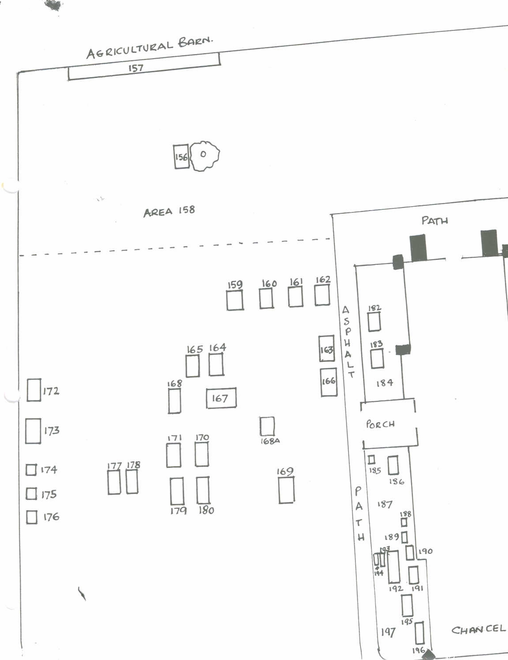

South west corner of the graveyard
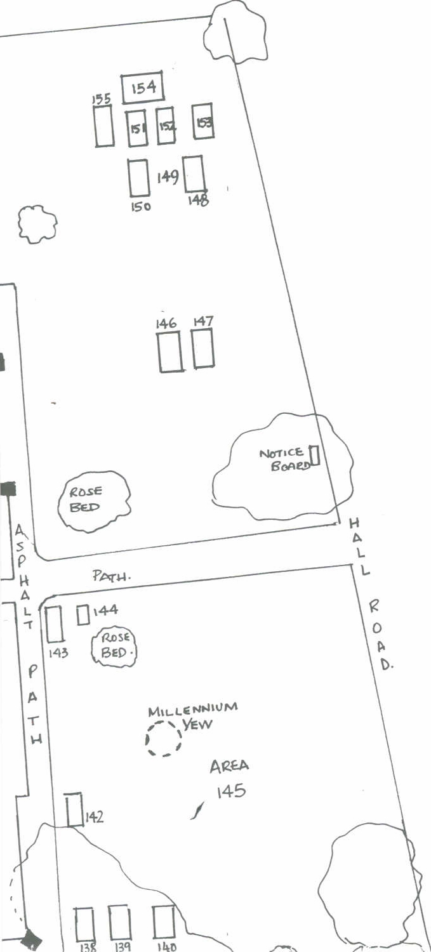

North west corner of the graveyard

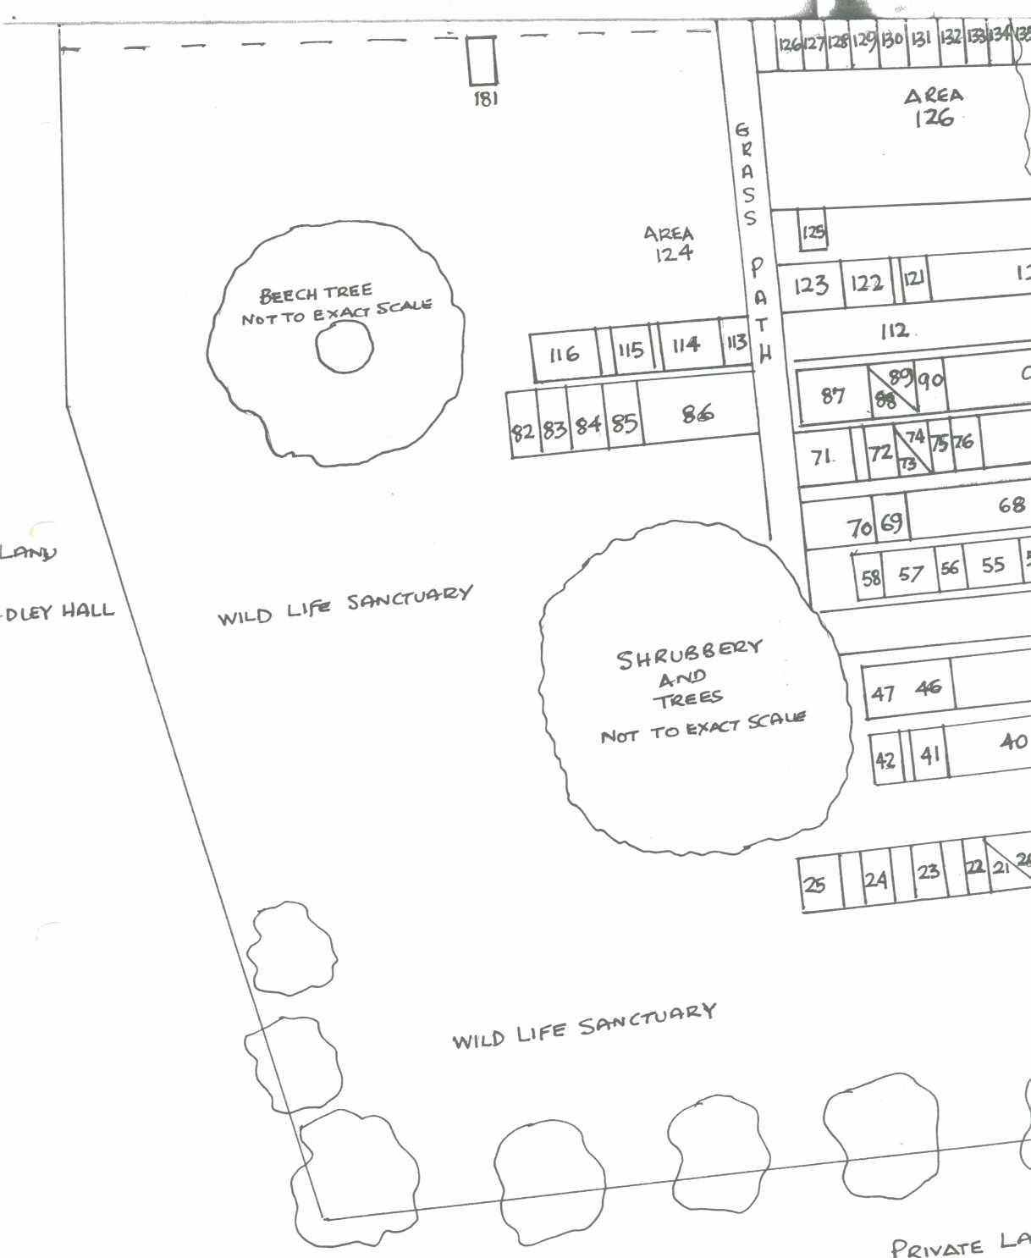
South east corner of the graveyard
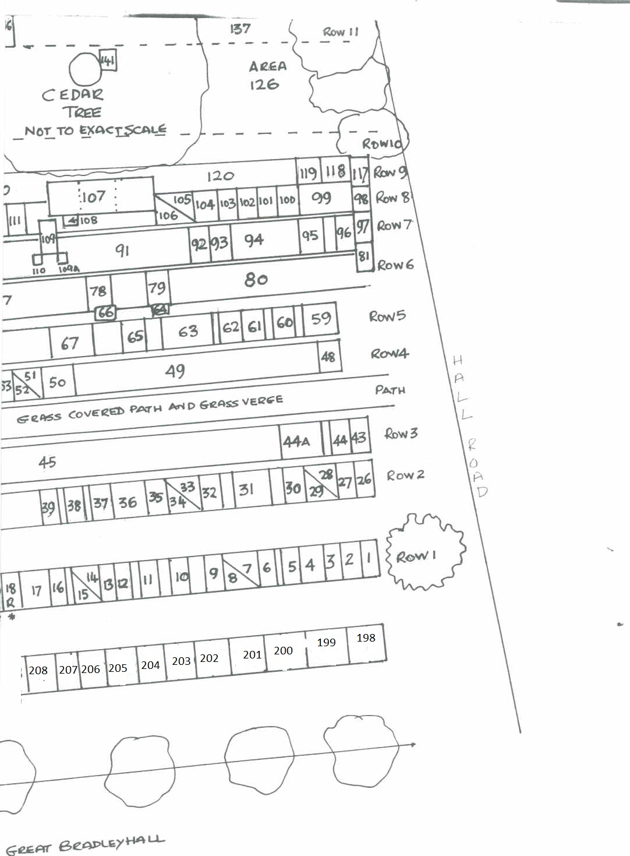

North east corner of the graveyard

